edited by airtraffic promotion group – a non-profit organization supported by aviation professionals

LATEST NEWS

SPOTTED AT JET AVIATION’S MAINTENANCE FACILITIES - Boeing 767-300 VP-BKS (Kalair/USA) in „Backstreet Boys“ livery. Future missions tailored to this aircraft are not known yet. All Boeing 767-fans let us know about the aircraft’s whereabouts !

SPOTTED AT CROSSAIR’S MAINTENANCE BASE - Embraer 145 HB-JAH, Crossair’s 8th Embraer Jet out of an order of 25 aircraft. HB-JAI is expected to arrive this month.

STATISTICS OCTOBER 2000 (PASSENGER / CARGO) need all details, please, let us know !

Scheduled Passengers 280‘427 +7% Flown Aircargo 7‘578 +10%
Charter Passengers 77‘831 -18% Trucked Aircargo 3‘900
Total incl. others 358'551 +/-0% Total Aircargo 11'479 + 4%
EuroCross transfers (Jan-Oct) 610‘384 +50% ExpressCargo (Jan-Oct) 17‘392 +10%

Total Jan-Oct 2000 3'273'749 +6% Total Jan-Oct 2000 101'454 +10%

10 HIGHLIGHTS OF THE RAMP DURING THE MONTH OF OCTOBER 2000

Date | Airline | Aircraft | Registration | Date | Airline | Aircraft | Registration
01.10.00 | French Air Force | C-130H | F-RAPE | 13.10.00 | Moldavian Airlines | Saab 340B | ER-SGB
02.10.00 | Atlantic Airways | L-188PF | G-FIJR | 20.10.00 | British World | BAC-1-11 | G-OBWD
04.10.00 | ABC Air Hungary | Let410 | HA-LAY | 21.10.00 | European Air Cargo | BAC-1-11 | G-AWYV
09.10.00 | Algerie Government | F-27-600 | 7T-VRN | 27.10.00 | Condor | B757-330 | D-ABOF
10.10.00 | MK Airlines | DC-8-62 | 9G-MKG | 28.10.00 | Gemini Air Cargo | MD11F | N701GC

This is a small selection of movements during the month of October, need all details, please let us know !!!

CONSTRUCTION SITES AT THE EUROAIRPORT

RUNWAY 26 is now being extended by 220 meters in length and 60 meters in width. The surface of the extented piece of runway will be non-concrete (Macadam). Runway 26 is primarily considered for take offs and for landings under gusty Westerly wind conditions. With the extention fully operational the airport wants to see more take offs on this runway under normal flight conditions in order to cut down on noise emissions over densely populated areas to the South of the airport.

NEW CATERING FACILITIES will be ready in Spring 2002. Construction is scheduled to start in February 2001. The new establishment is set to handle 25000 meals per day in its final stage of planning and operations. A large number of cabin caterings exceeding 600 units a day must also be prepared at this site. The two storey building accounting for 8000 square meters will offer sufficient space for additional traffic. Presently a staff of 258 people are working for Gate Gourmet’s catering division at the EuroAirport.
A decisive change to the present facility will be the location of the new site (approx. 350 meters in distance to the tarmac area). The fate of the catering now in service is wide open after Spring 2002.

SHELTERED CAR PARKING will soon be available. In the first phase 400 parking positions on the French sector will go into service this month. The same number of parking positions are under construction in the Swiss sector in a second phase. Their ribbon-cutting will take place in the second half of 2001.
Page 1/2

FOR THE ENTHUSIASTS‘ DELIGHT

WELCOME TO THE BELVEDERE. The large community of aviation enthusiasts and those eager to be as close to the action as possible (landing and taking off of aircraft) have warmly welcomed a newly built observation platform located near the touchdown zone of runway 16. In no time the spot has become a place for family outings and other events (1).

Fellow aviation enthusiasts have these comments ready for anyone interested in them :

„A visit to the site may be fueling the hearts and minds of „future generation pilots“ with all their hopes and dreams“.

„Wandering around at the place and hearing many youngsters enthusiastically commenting all the landing and departing airplanes, I got the notion that the initiative which went into this project is well spent“

„Following the advice of a fellow I got in touch with the kids who were profoundly discussing the latest events in the aviation scene“.
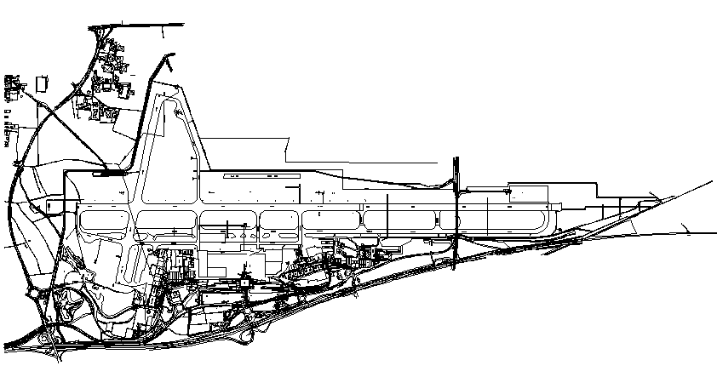
How do I get there ?
- Belvedere: take route RD 12bis from the airport terminal (rue de Châlet) – underpassing runway 16 – car parking is possible right after the tunnel – coming from the village of Blotzheim follow airport signs – stop at road cross rail tracks (on your left side shortly after the statue) – car parking alongside of dirt road
- Runway 34: take route RD 105 from St. Louis to Hésingue – stop at center line marker for runway 34 (yellow pylons) – take dirt road to the right until reaching fence – no car parking
- Visitors Deck: Observation deck for visitors Swiss side – free of charge – take exit from restaurant 5th floor – open at daytime from 9am onwards to sunset (in Winter)

CARGO NEWS

DHL HAS STARTED a second flight into the EuroAirport Hub. The Convair 580 freighter is scheduled to arrive at 6 am and to depart again at 10.15 pm. The service is operated four times a week between Malaga, Vitoria, Metz-and Basel (EuroAirport). At Metz Airport the plane is meeting three other DHL aircraft – another Convair 580 (Nice-Metz-Cologne) and two Lockheed Electras (Marseille-Metz-East Midlands and Toulouse-Metz-Brussels vv.). Metz-Nancy-Lorraine Airport has been chosen by DHL as Upper Rhine Valley gateway which was originally planned at Strassburg some years ago. The plan was heavily opposed, however. The EAP-gateway is serving primarily the Swiss market, only 10% of the volume is EC-generated.

UNITED PARCEL SERVICES (UPS) has reduced its weekly express cargo services out of Basel (EuroAirport) to Cologne from two flights on weekdays to one, operated by WDL Aviation (Fokker 27).

INTERNA

If you wish to register to our newsletter (old and new ones), please send us a mail to the addresses below. Your request will be
processed immediately.

Nicholas Degen at ndegen@datacomm.ch or Willfried Schmid at wischmid@datacomm.ch

Good advice has reached our desk ! – Capital writing has been abandoned and replaced by today’s standards for newsletter style. Thank you very much for this feedback. For other/further upgrades we welcome your ideas anytime.
Page 2/2

